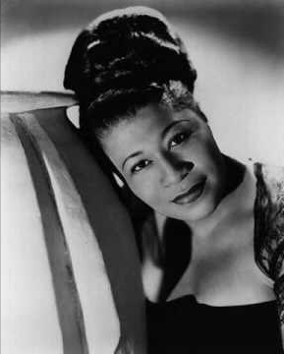
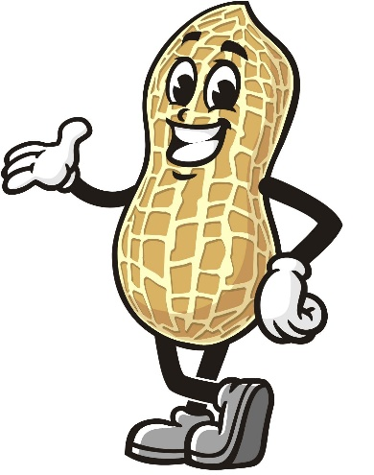

Tonight at 6:30 p.m. Oct 10, 2024
Get ready for a journey through the golden era with our set of big band hits from yesteryear featuring Ella Fitzgerald.

Mixed Nuts

Tonight at 6:30 p.m. Oct 10, 2024
Get ready for a journey through the golden era with our set of big band hits from yesteryear featuring Ella Fitzgerald.

